**Exercise 1: Ranking and Window Functions**

**SQL CODE :**

**To create Table:**

CREATE TABLE ElectronicDevices (

DeviceID INT PRIMARY KEY,

DeviceName VARCHAR(50),

Category VARCHAR(50),

Price INT

);

INSERT INTO ElectronicDevices (DeviceID, DeviceName, Category, Price) VALUES

(201, 'iPhone 14', 'Mobile', 80000),

(202, 'Samsung Galaxy S21', 'Mobile', 75000),

(203, 'OnePlus 11', 'Mobile', 75000),

(204, 'Dell XPS 13', 'Laptop', 95000),

(205, 'HP Pavilion', 'Laptop', 85000),

(206, 'Lenovo ThinkPad', 'Laptop', 95000),

(207, 'Sony Bravia', 'Television', 60000),

(208, 'LG OLED', 'Television', 70000),

(209, 'Samsung QLED', 'Television', 70000);

SELECT * FROM ElectronicDevices;

**Output:**

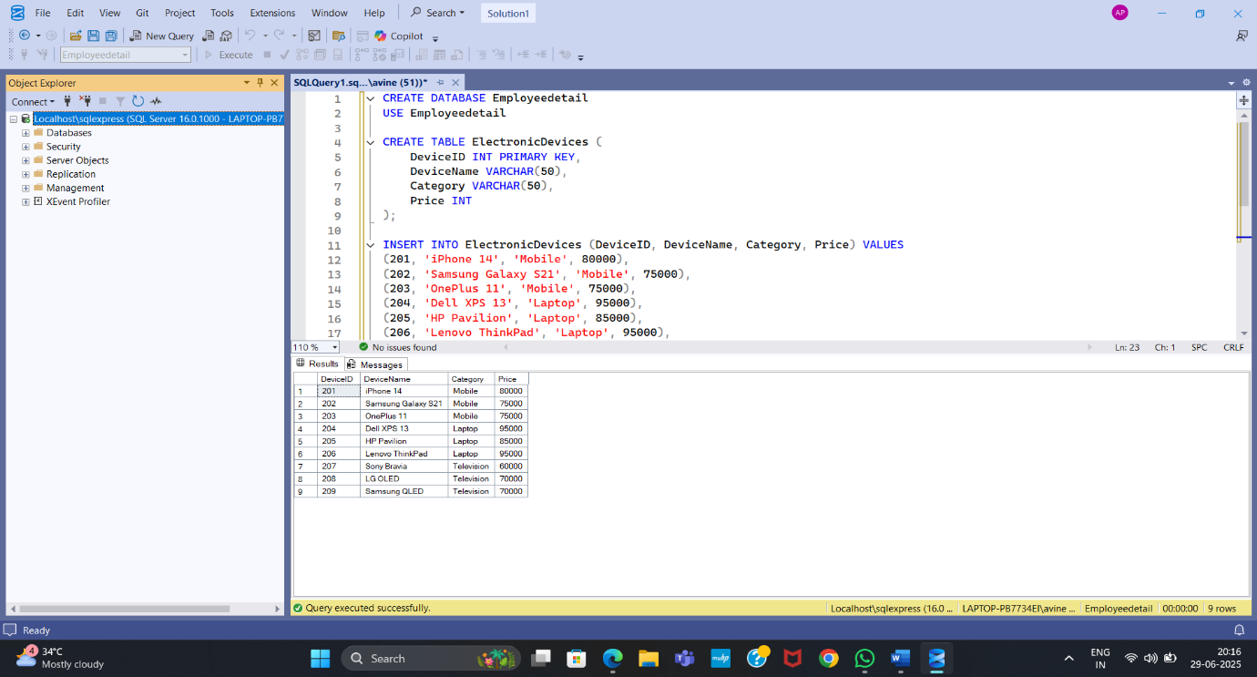

**RANK():**

SELECT

DeviceID,

DeviceName,

Category,

Price,

RANK() OVER (PARTITION BY Category ORDER BY Price DESC) AS PriceRank

FROM ElectronicDevices;

**Output :** 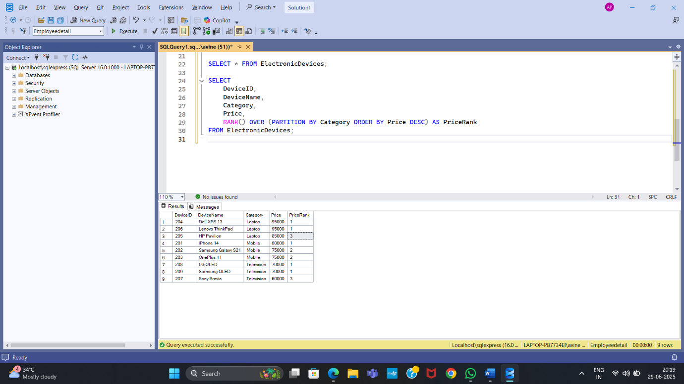

**DENSE RANK:**

SELECT

DeviceID,

DeviceName,

Category,

Price,

DENSE_RANK() OVER (PARTITION BY Category ORDER BY Price DESC) AS DensePriceRank

FROM ElectronicDevices;

**OUTPUT:** 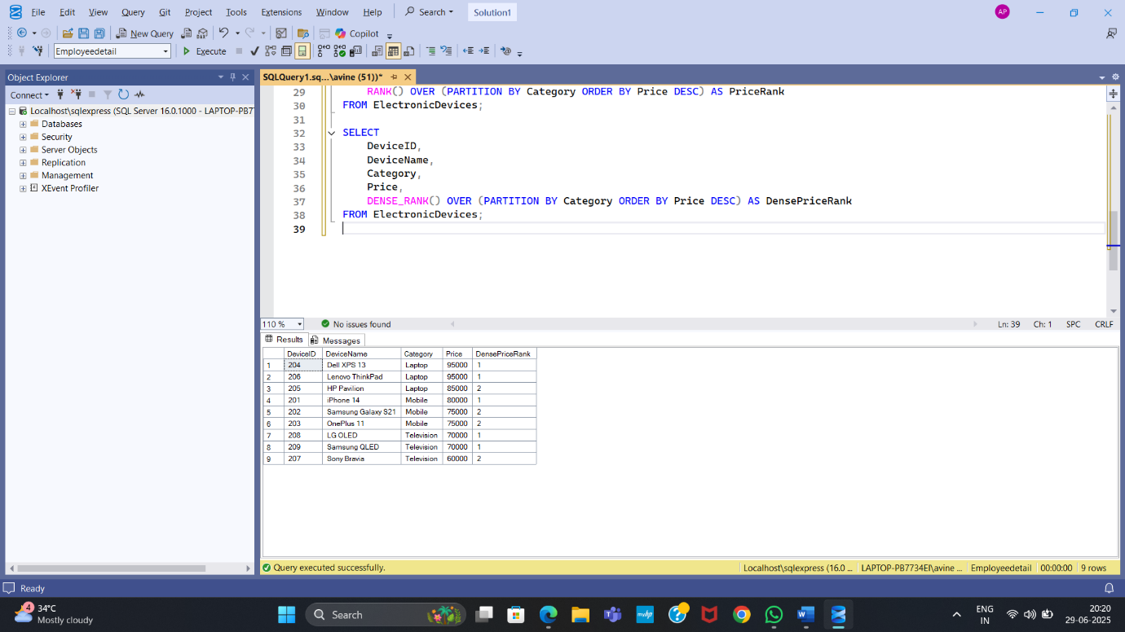

**ROW NUMBER:**

SELECT

DeviceID,

DeviceName,

Category,

Price,

ROW_NUMBER() OVER (PARTITION BY Category ORDER BY Price DESC) AS RowNum

FROM ElectronicDevices;

**OUTPUT:** 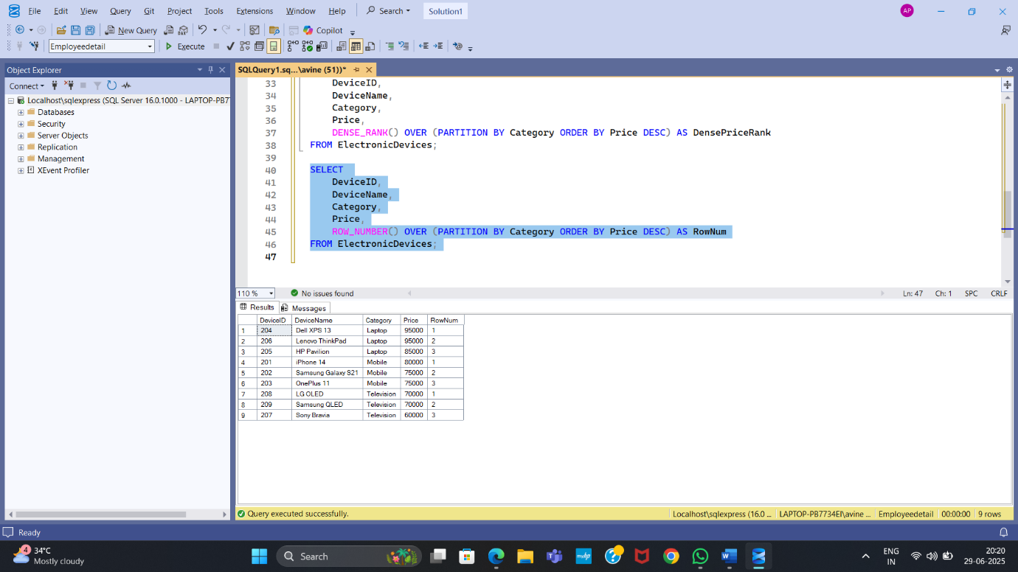

**Exercise 1: Create a Stored Procedure**

**SQL CODE:**

IF OBJECT_ID('dbo.GetRankedDevices', 'P') IS NOT NULL

DROP PROCEDURE dbo.GetRankedDevices;

GO

CREATE PROCEDURE dbo.GetRankedDevices

AS

BEGIN

SELECT

DeviceID,

DeviceName,

Category,

Price,

RANK() OVER (PARTITION BY Category ORDER BY Price DESC) AS PriceRank,

DENSE_RANK() OVER (PARTITION BY Category ORDER BY Price DESC) AS DensePriceRank,

ROW_NUMBER() OVER (PARTITION BY Category ORDER BY Price DESC) AS RowNum

FROM dbo.ElectronicDevices;

END;

GO

**OUTPUT:**

